

NAME: BISMA FATIMA
CLASS: CS A
ROLL NO: F24605036
COURSE: OBJECT ORIENTED PROGRAMMING
COURSE CODE: CS-123
LECTURER: MISS TAYYABA KALSOOM

Post LAB 06

TASK 06
PROGRAM
1. import java.util.Scanner;
2.
3. class Employee {
4. private String name;
5. private int id;
6. private double salary;
7.
8. // Default constructor
9. public Employee() {
10. this.name = "Unknown";
11. this.id = 0;
12. this.salary = 1000;
13. }
14.
15. // Parameterized constructor with name and ID
16. public Employee(String name, int id) {
17. this.name = name;
18. this.id = id;
19. this.salary = 5000;
20. }
21.
22. // Parameterized constructor with name, ID, and salary
23. public Employee(String name, int id, double salary) {
24. this.name = name;
25. this.id = id;
26. this.salary = salary;
27. }
28.
29. // Method to display employee details
30. public void displayDetails() {
31. System.out.println("Name: " + name);
32. System.out.println("ID: " + id);
33. System.out.println("Salary: $" + salary);
34. }
35.
36. // Method to display employee details with a custom message
37. public void displayDetails(String message) {
38. System.out.println(message + " Name: " + name + ", ID: " + id + ", Salary: $" + salary);
39. }
40. }
41.
42. public class Main {
43. public static void main(String[] args) {
44. Scanner scanner = new Scanner(System.in);
45.
46. // Create Employee objects using different constructors
47. Employee employee1 = new Employee();
48. Employee employee2 = new Employee("John Doe", 101);
49. Employee employee3 = new Employee("Jane Doe", 102, 6000);
50.
51. // Ask user to enter details for employee4
52. System.out.print("Enter name: ");
53. String name = scanner.nextLine();
54. System.out.print("Enter ID: ");
55. int id = scanner.nextInt();
56. System.out.print("Enter salary: ");
57. double salary = scanner.nextDouble();
58. scanner.nextLine(); // Consume newline left-over
59.
60. Employee employee4 = new Employee(name, id, salary);
61.
62. // Display employee details
63. System.out.println("Employee 1 Details:");
64. employee1.displayDetails();
65.
66. System.out.println("\nEmployee 2 Details:");
67. employee2.displayDetails("Welcome, ");
68.
69. System.out.println("\nEmployee 3 Details:");
70. employee3.displayDetails();
71.
72. System.out.println("\nEmployee 4 Details:");
73. employee4.displayDetails("Hello, ");
74. }
75. }

OUTPUT
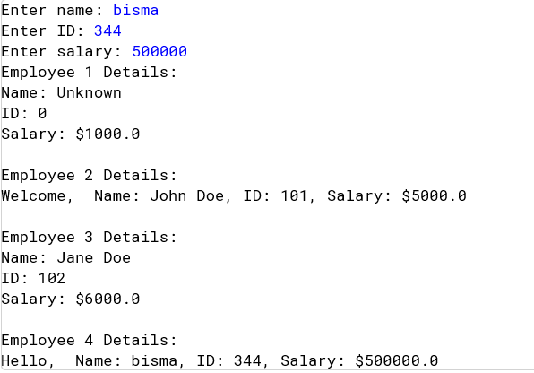

TASK 07
PROGRAM
1. class A {
2. int a;
3. String b;
4. A() {
5. a = 10;
6. this.b = "LearnCoding";
7. System.out.println(a+""+ b);
8. }
9. A(A ref) {
10. a = ref.a;
11. b = ref.b;
12. System.out.println(a +""+ b);
13. }
14. }
15. class B {
16. public static void main(String[] args) {
17. A obj1 = new A(); // Calls the default constructor
18. A obj2 = new A(obj1); // Calls the copy constructor
19. }
20. }
21.

OUTPUT
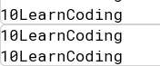

TASK 08
PROGRAM
1. import java.util.Scanner;
2.
3. class Address {
4. private String street;
5. private String city;
6. private String state;
7. private int zip;
8.
9. public Address(String street, String city, String state, int zip) {
10. this.street = street;
11. this.city = city;
12. this.state = state;
13. this.zip = zip;
14. }
15.
16. public void setStreet(String street) {
17. this.street = street;
18. }
19.
20. public String getStreet() {
21. return street;
22. }
23.
24. public String getCity() {
25. return city;
26. }
27.
28. public String getState() {
29. return state;
30. }
31.
32. public int getZip() {
33. return zip;
34. }
35. }
36.
37. public class Person {
38. private String name;
39. private int age;
40. private Address address;
41.
42. // Parameterized constructor
43. public Person(String name, int age, Address address) {
44. this.name = name;
45. this.age = age;
46. this.address = address;
47. }
48.
49. // Copy constructor
50. public Person(Person person) {
51. this.name = person.name;
52. this.age = person.age;
53. this.address = person.address; // Shallow copy
54. }
55.
56. public void displayDetails() {
57. System.out.println("Name: " + name);
58. System.out.println("Age: " + age);
59. System.out.println("Address: " + address.getStreet() + ", " + address.getCity() + ", " + address.getState() + " " + address.getZip());
60. }
61.
62. public static void main(String[] args) {
63. Scanner scanner = new Scanner(System.in);
64.
65. System.out.print("Enter name: ");
66. String name = scanner.nextLine();
67.
68. System.out.print("Enter age: ");
69. int age = scanner.nextInt();
70. scanner.nextLine(); // Consume newline left-over
71.
72. System.out.print("Enter street: ");
73. String street = scanner.nextLine();
74.
75. System.out.print("Enter city: ");
76. String city = scanner.nextLine();
77.
78. System.out.print("Enter state: ");
79. String state = scanner.nextLine();
80.
81. System.out.print("Enter zip: ");
82. int zip = scanner.nextInt();
83. scanner.nextLine(); // Consume newline left-over
84.
85. Address address = new Address(street, city, state, zip);
86. Person person1 = new Person(name, age, address);
87. Person person2 = new Person(person1); // Create a copy of person1
88.
89. System.out.println("\nPerson 1 Details:");
90. person1.displayDetails();
91.
92. System.out.println("\nPerson 2 Details:");
93. person2.displayDetails();
94.
95. // Modify the address object of person1
96. address.setStreet("456 Broadway");
97.
98. System.out.println("\nAfter modifying person1's address:");
99. System.out.println("Person 1 Details:");
100. person1.displayDetails();
101.
102. System.out.println("\nPerson 2 Details:");
103. person2.displayDetails(); // person2's address is also modified due to shallow copy
104. }
105. }

OUTPUT
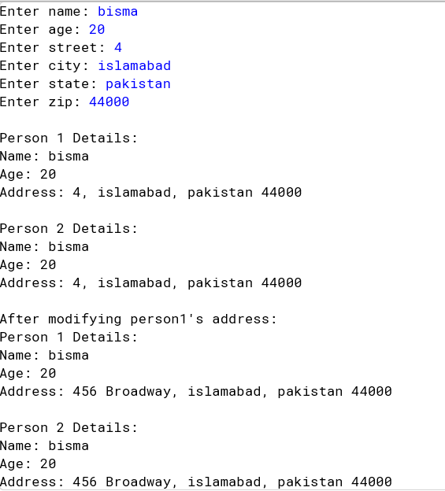

TASK 09
PROGRAM
1. public class Book {
2. private String title;
3. private String author;
4. private int publicationYear;
5.
6. // Default constructor
7. public Book() {
8. this.title = "Unknown";
9. this.author = "Unknown";
10. this.publicationYear = 0;
11. }
12.
13. // Constructor with title and author
14. public Book(String title, String author) {
15. this.title = title;
16. this.author = author;
17. this.publicationYear = 0;
18. }
19.
20. // Constructor with title, author, and publicationYear
21. public Book(String title, String author, int publicationYear) {
22. this.title = title;
23. this.author = author;
24. this.publicationYear = publicationYear;
25. }
26.
27. // Copy constructor
28. public Book(Book book) {
29. this.title = book.title;
30. this.author = book.author;
31. this.publicationYear = book.publicationYear;
32. }
33.
34. // Getter methods
35. public String getTitle() {
36. return title;
37. }
38.
39. public String getAuthor() {
40. return author;
41. }
42.
43. public int getPublicationYear() {
44. return publicationYear;
45. }
46.
47. public void setPublicationYear(int publicationYear) {
48. this.publicationYear = publicationYear;
49. }
50.
51. public static void main(String[] args) {
52. // Create Book objects
53. Book book1 = new Book();
54. Book book2 = new Book("The Hitchhiker's Guide to the Galaxy", "Douglas Adams");
55. Book book3 = new Book("Pride and Prejudice", "Jane Austen", 1813);
56. Book copiedBook = new Book(book3);
57.
58. // Display Book information
59. System.out.println("Book 1 Information:");
60. System.out.println("Title: " + book1.getTitle());
61. System.out.println("Author: " + book1.getAuthor());
62. System.out.println("Publication Year: " + book1.getPublicationYear());
63. System.out.println();
64.
65. System.out.println("Book 2 Information:");
66. System.out.println("Title: " + book2.getTitle());
67. System.out.println("Author: " + book2.getAuthor());
68. System.out.println("Publication Year: " + book2.getPublicationYear());
69. System.out.println();
70.
71. System.out.println("Book 3 Information:");
72. System.out.println("Title: " + book3.getTitle());
73. System.out.println("Author: " + book3.getAuthor());
74. System.out.println("Publication Year: " + book3.getPublicationYear());
75. System.out.println();
76.
77. System.out.println("Copied Book Information:");
78. System.out.println("Title: " + copiedBook.getTitle());
79. System.out.println("Author: " + copiedBook.getAuthor());
80. System.out.println("Publication Year: " + copiedBook.getPublicationYear());
81. System.out.println();
82.
83. // Modify the original book and display the changes
84. book3.setPublicationYear(1817);
85.
86. System.out.println("After modifying Book 3:");
87. System.out.println("Book 3 Information:");
88. System.out.println("Title: " + book3.getTitle());
89. System.out.println("Author: " + book3.getAuthor());
90. System.out.println("Publication Year: " + book3.getPublicationYear());
91. System.out.println();
92.
93. System.out.println("Copied Book Information:");
94. System.out.println("Title: " + copiedBook.getTitle());
95. System.out.println("Author: " + copiedBook.getAuthor());
96. System.out.println("Publication Year: " + copiedBook.getPublicationYear());
97. }
98. }
99.

OUTPUT
